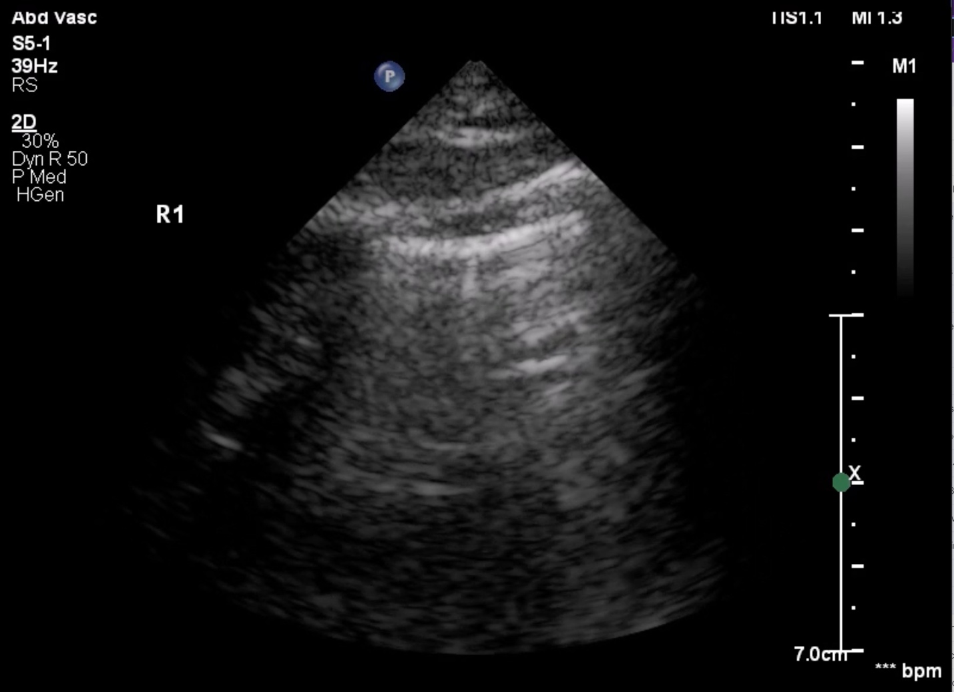

Figure S1: Still image taken from Video 1 of a sonographically normal R1 view. Note that still images are generally insufficient for anterior and anterior-lateral lung ultrasound evaluation because evaluating lung ultrasound for pathology requires screening for dynamic findings such as lung pulse and lung sliding.

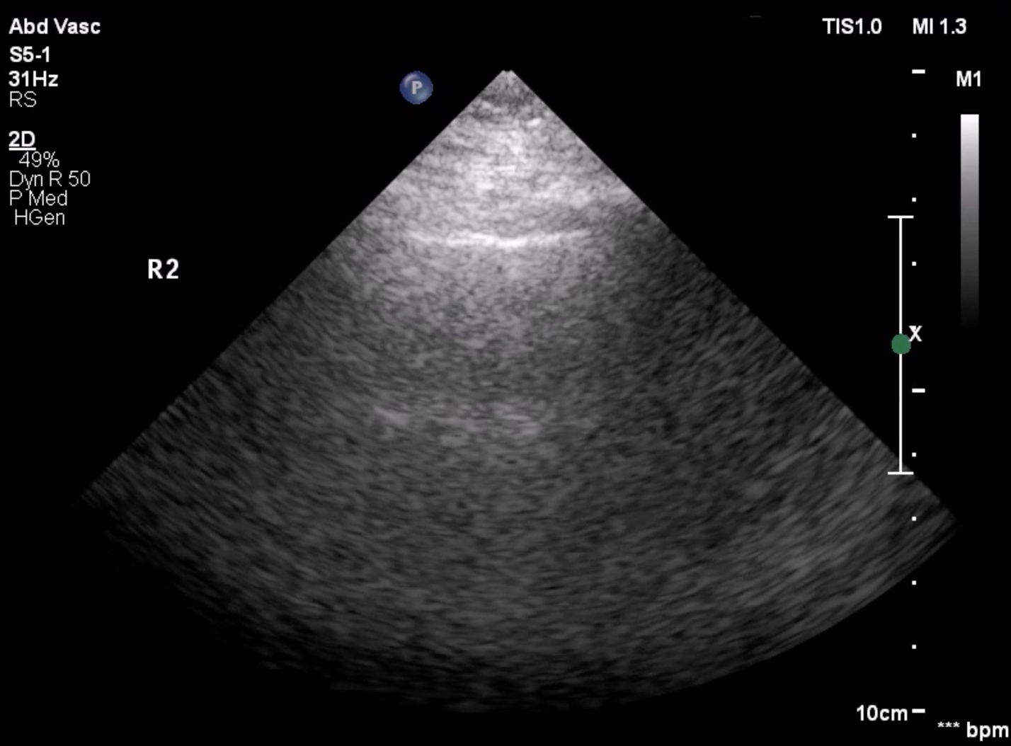

Figure S2: Still image taken from Video 2 of a sonographically normal R2 view. Note that still images are generally insufficient for anterior and anterior-lateral lung ultrasound evaluation because evaluating lung ultrasound for pathology requires screening for dynamic findings such as lung pulse and lung sliding.

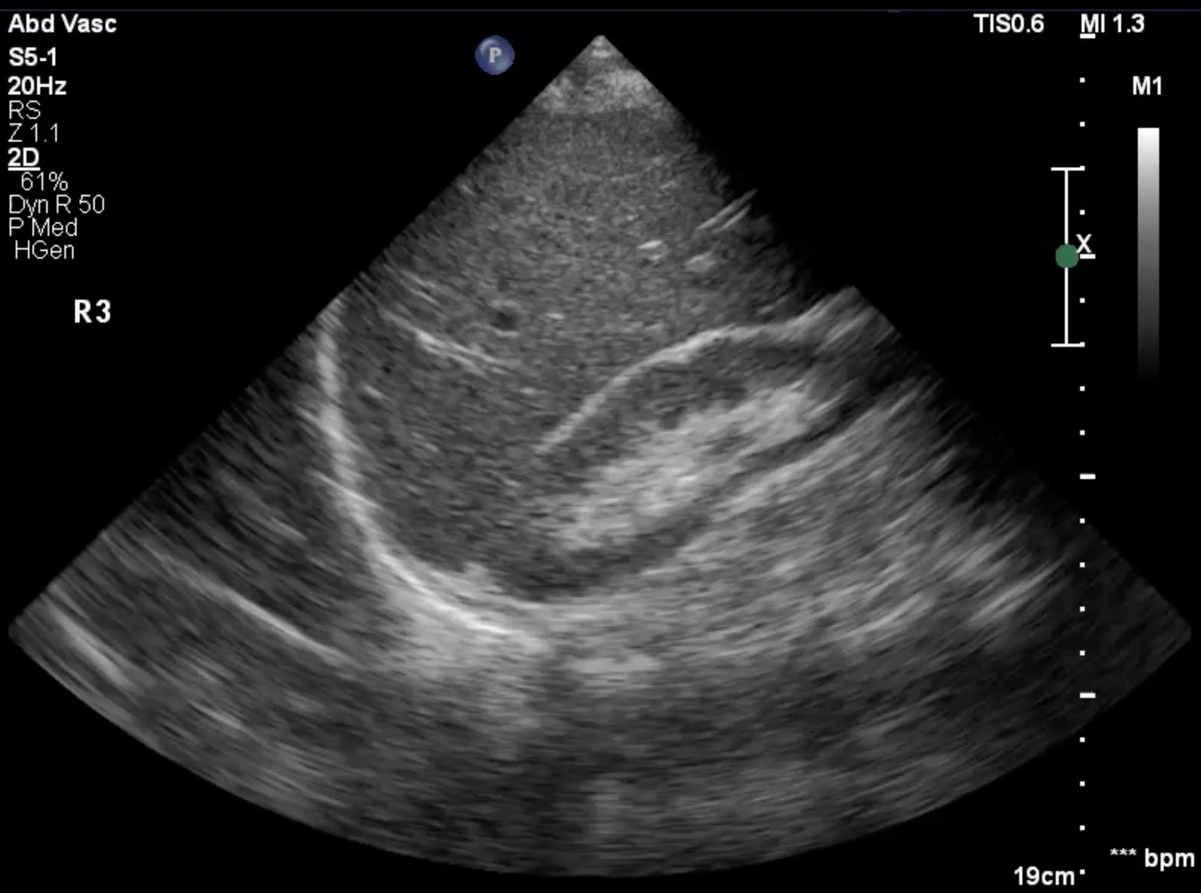

Figure S3: Still image taken from Video 3 of a sonographically normal R3 view.

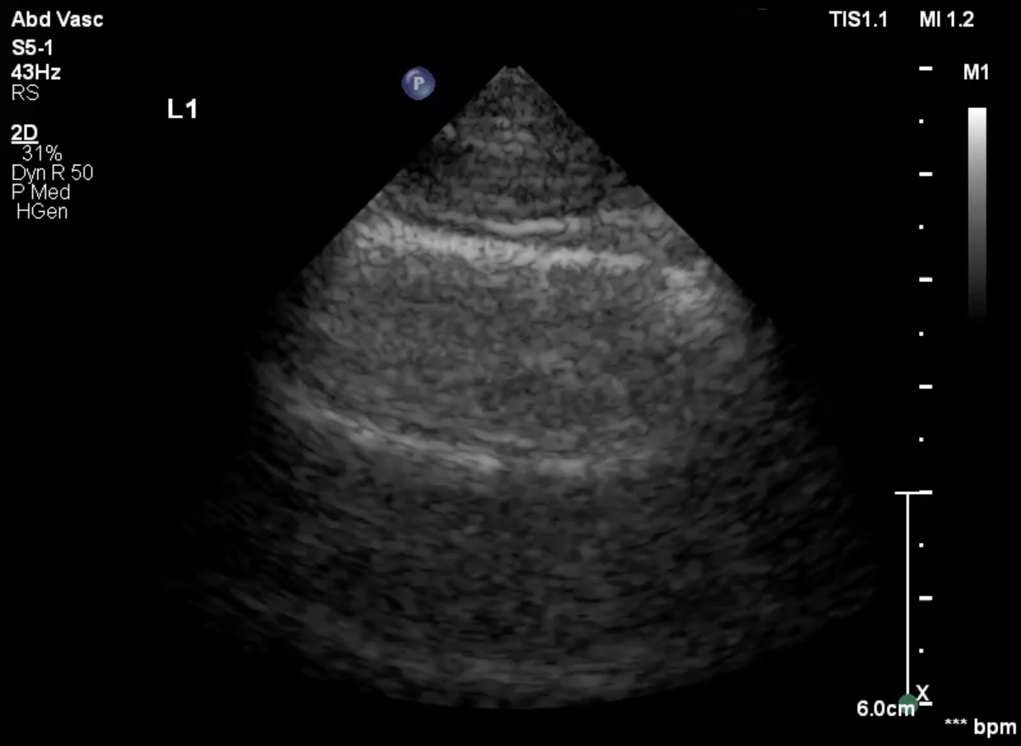

Figure S4: Still image taken from Video 4 of a sonographically normal L1 view. Note that still images are generally insufficient for anterior and anterior-lateral lung ultrasound evaluation because evaluating lung ultrasound for pathology requires screening for dynamic findings such as lung pulse and lung sliding.

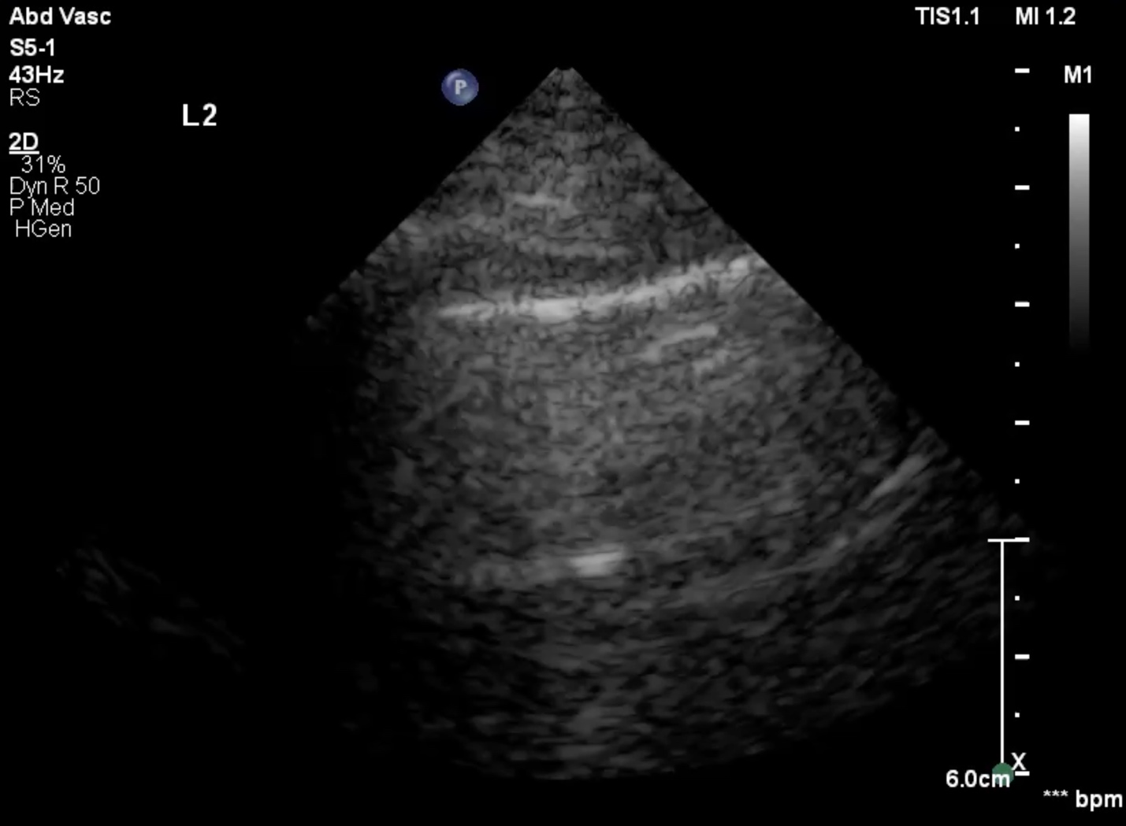

Figure S5: Still image taken from Video 5 of a sonographically normal L2 view. Note that still images are generally insufficient for anterior and anterior-lateral lung ultrasound evaluation because evaluating lung ultrasound for pathology requires screening for dynamic findings such as lung pulse and lung sliding.

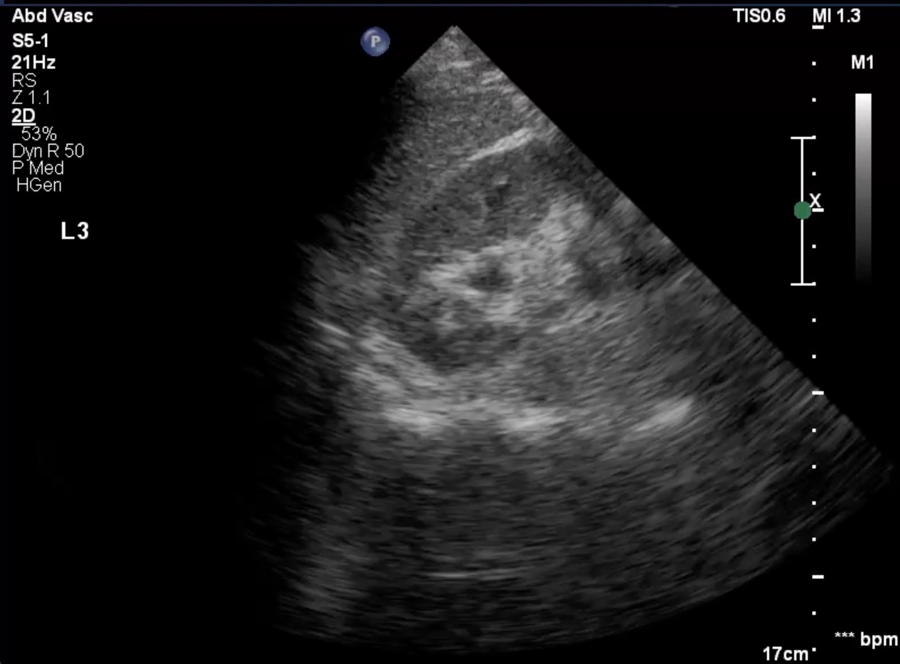

Figure S6: Still image taken from Video 6 of a sonographically normal L3 view.

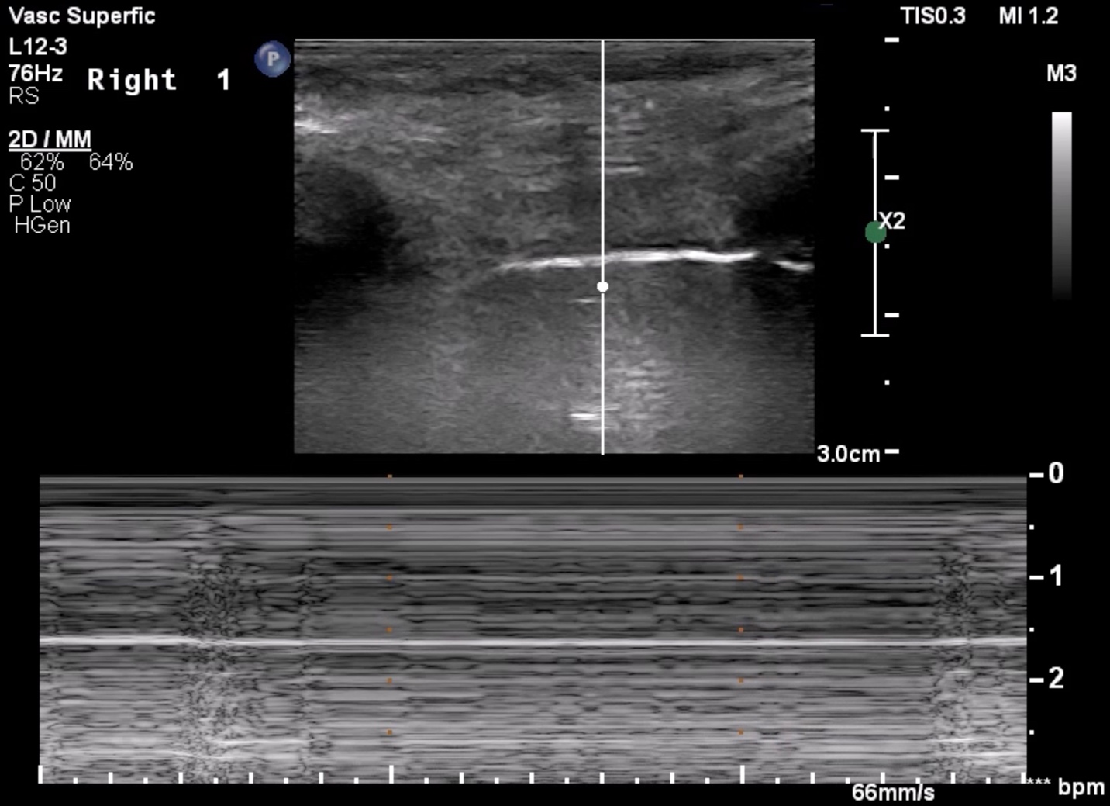

Figure S7: Still image taken from Video 7 of a pneumothorax being evaluated using M-mode. Notably, both the live M-mode clip and the still image show findings that are ambiguous for pneumothorax, which is a common problem in our experience when trying to use M-mode for pneumothorax evaluation: M-mode frequently produces ambiguous findings.

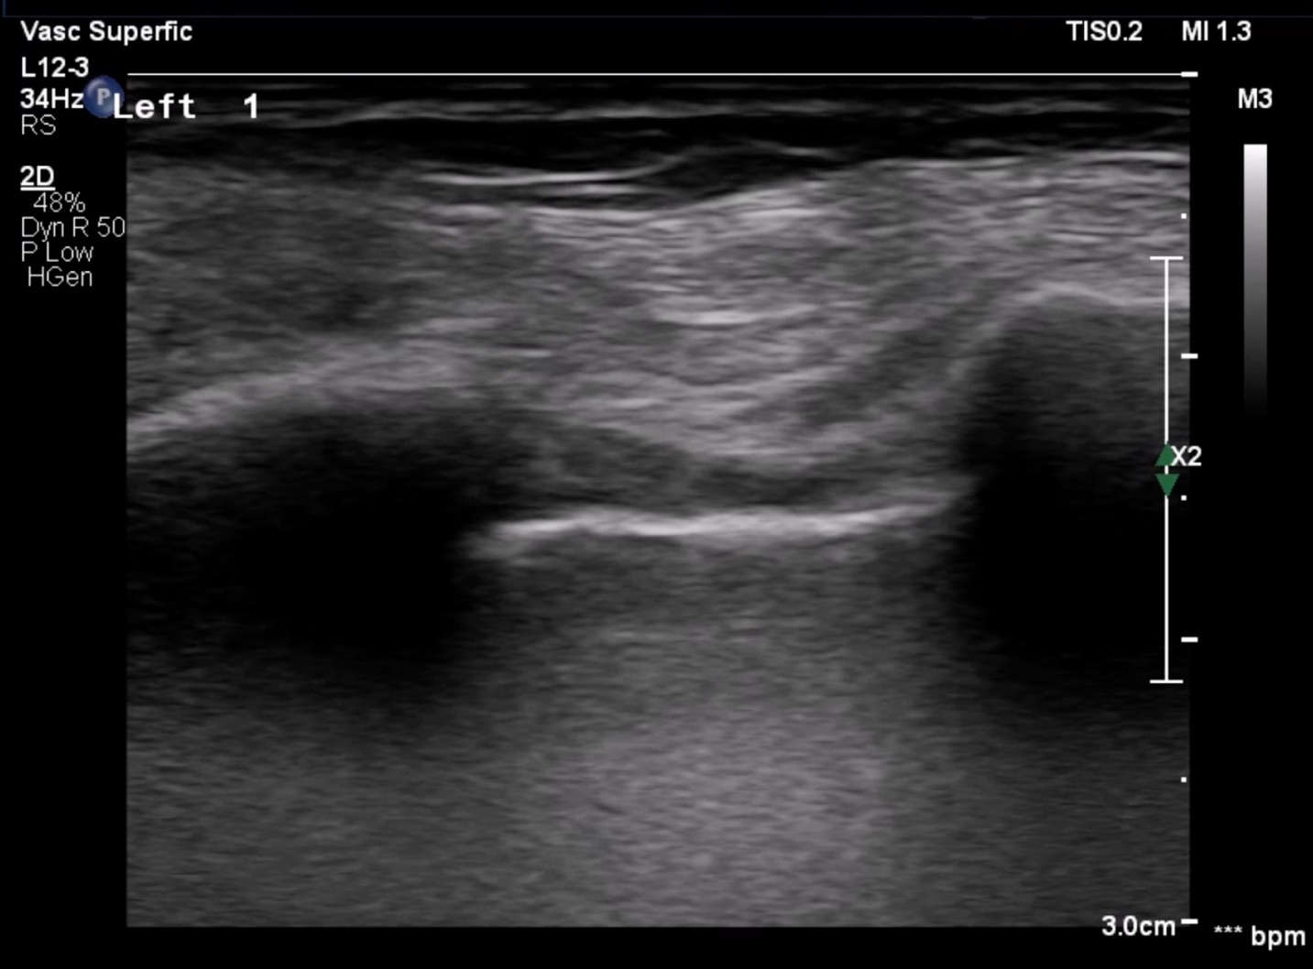

Figure S8: Still image taken from Video 8, which is an explanatory video about screening for pneumothorax. Note screening for pneumothorax requires video clips rather than still images to evaluate for dynamic findings such as lung pulse and lung sliding.
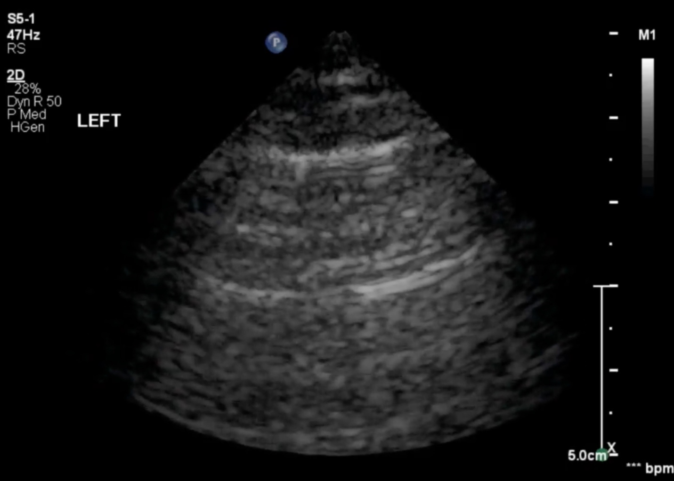

Figure S9: Still image taken from Video 9. Although Video 9 clearly demonstrates a lung point, note that this still image is largely unhelpful because screening for pneumothorax requires video clips rather than still images to evaluate for dynamic findings such as lung pulse and lung sliding.
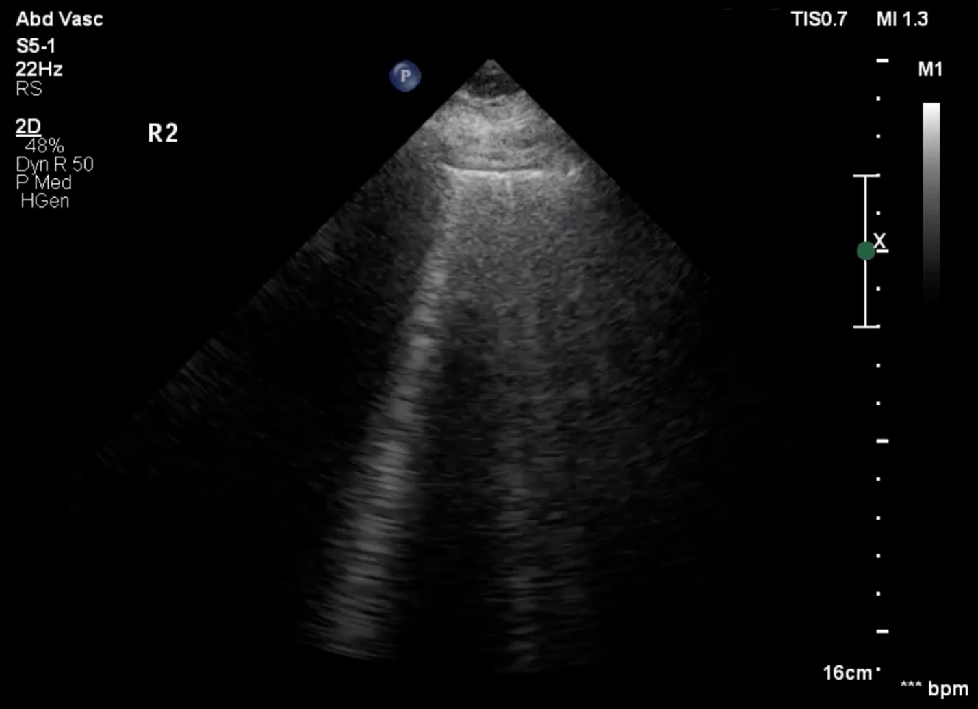

Figure S10: Still image taken from Video 10 of an R2 view with multiple (≥3) B-lines in one rib interspace.
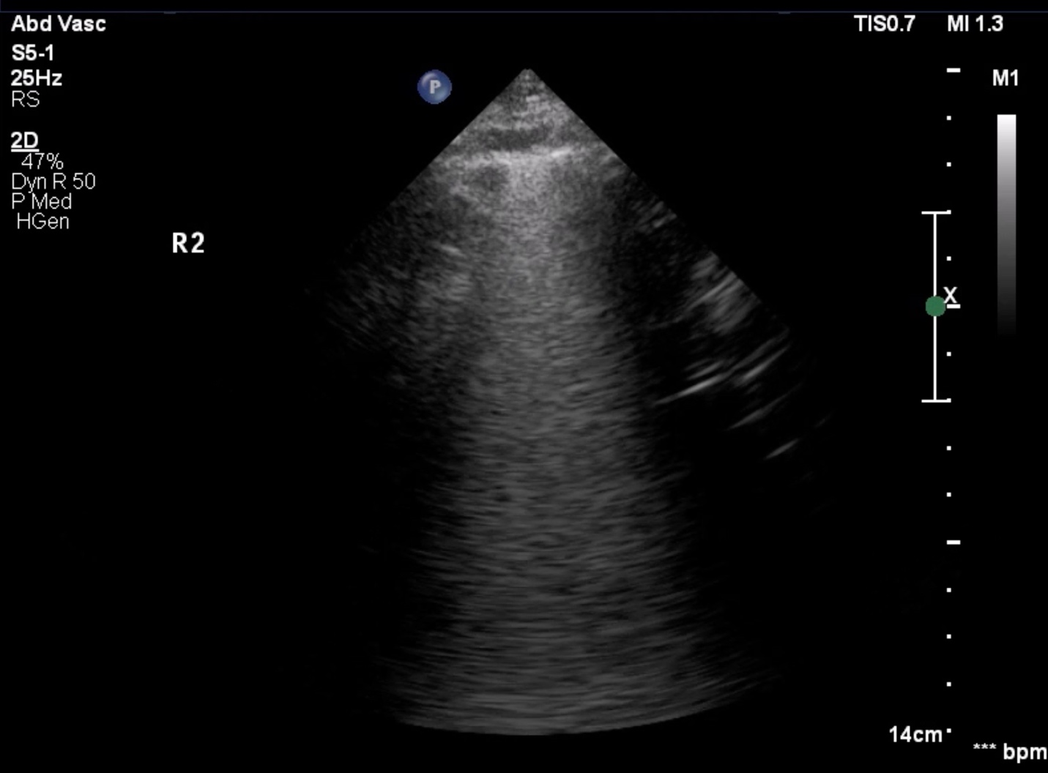

Figure S11: Still image taken from Video 11 of an R2 view with a single large, confluent B-line occupying ≥50% of one rib interspace.
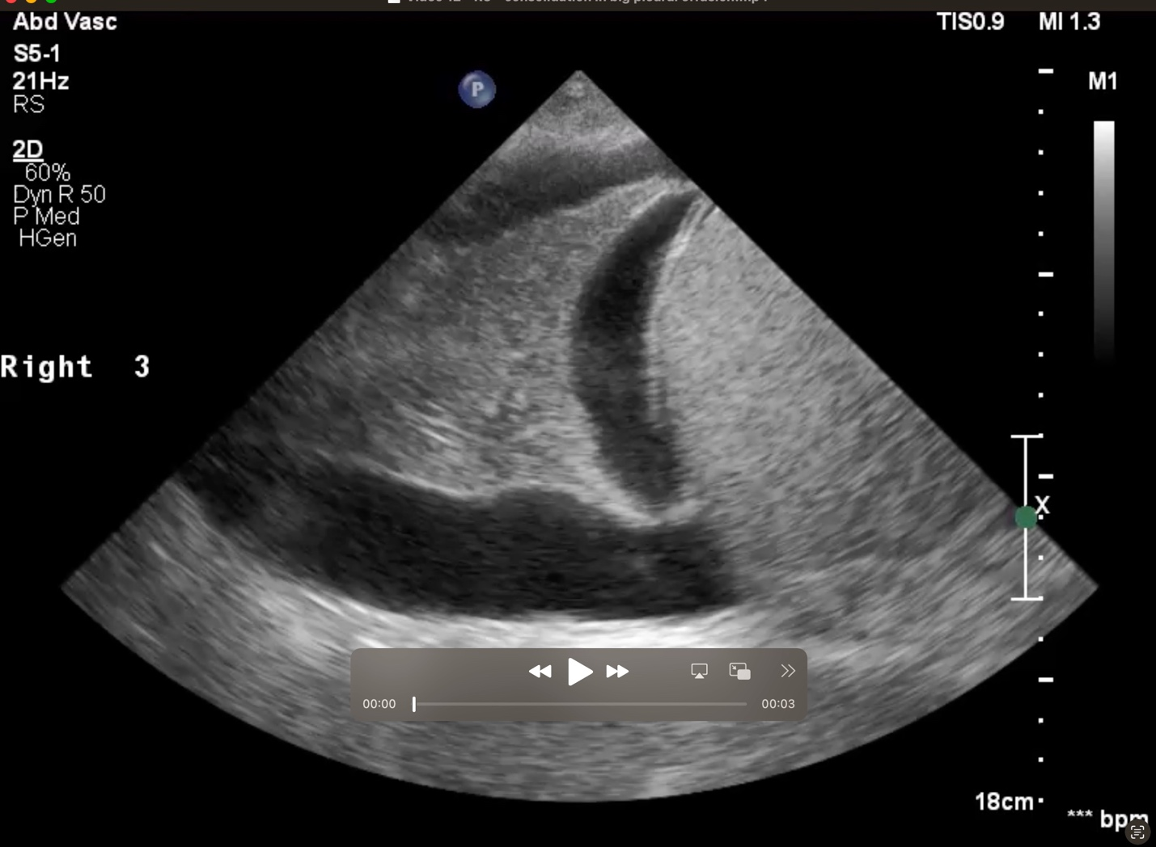

Figure S12: Still image taken from Video 12 of a lung consolidation floating inside a pleural effusion.
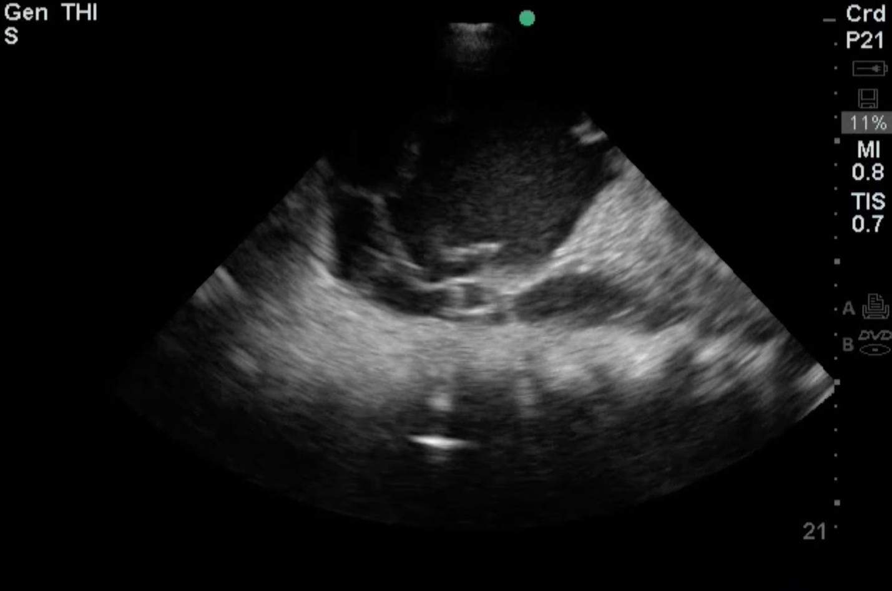

Figure S13: Still image taken from Video 13 of lung consolidation floating inside a homogenously hyperechoic pleural effusion, which turned out to be hemothorax.

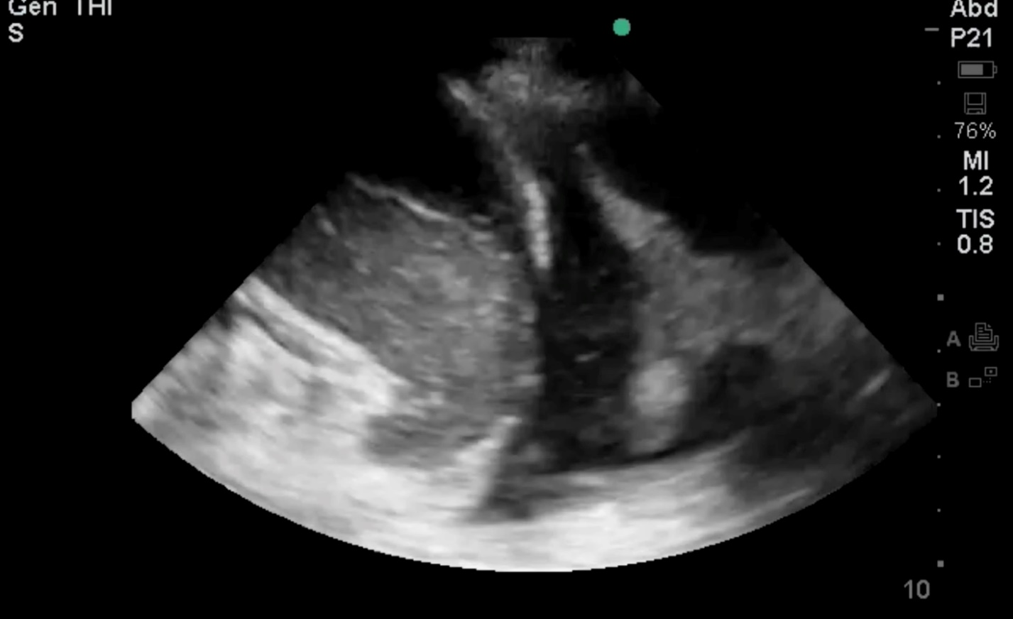

Figure S14: Still image taken from Video 14 of pleural fluid containing internal debris. The presence of internal debris suggests that the fluid is likely exudative.
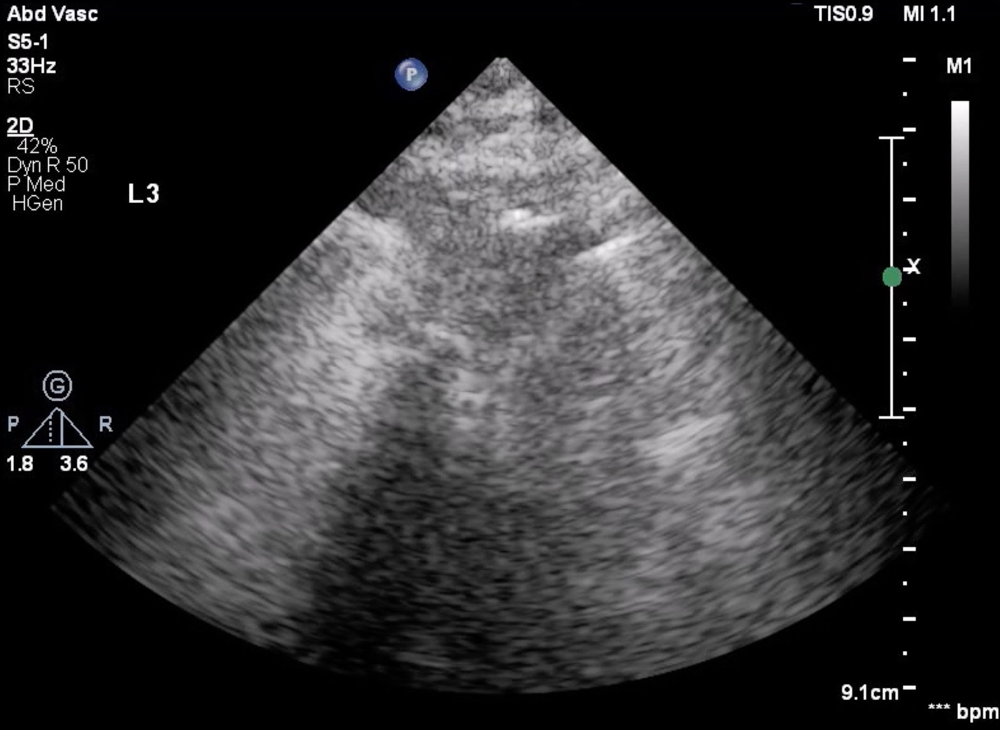

Figure S15: Still image taken from Video 15 of “shred sign” - an irregular hyperechoic line (“fractal line”) in the middle of the lung parenchyma from which vertical ring-down artifacts propagate.

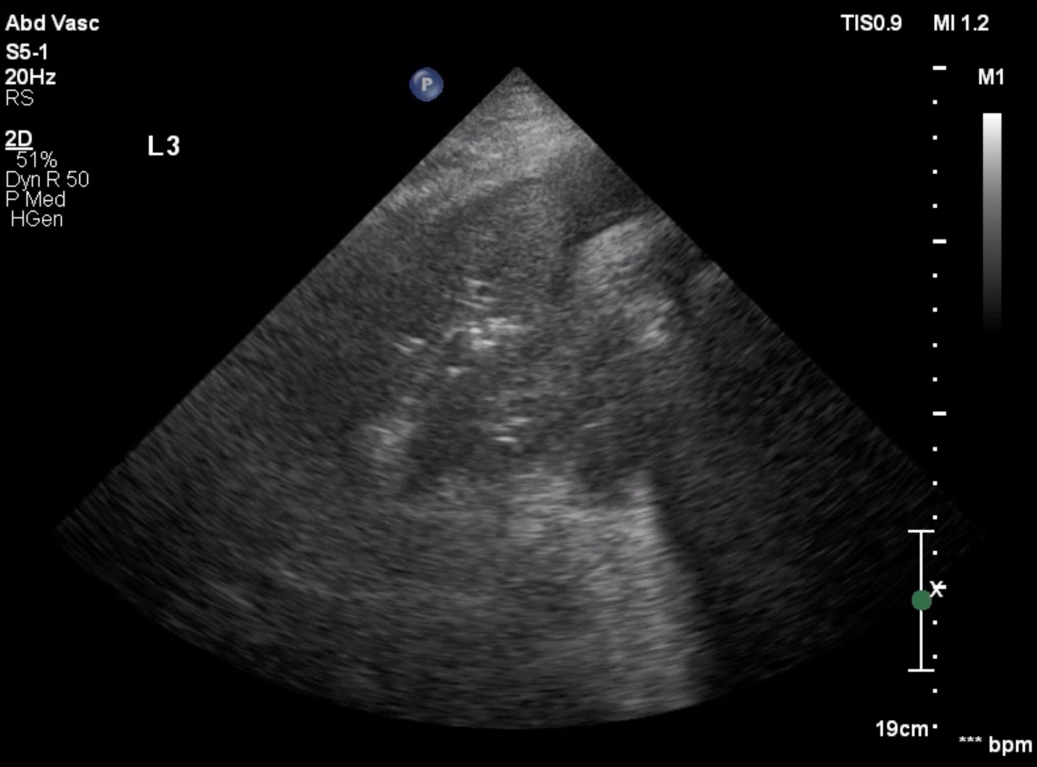

Figure S16: Still image taken from Video 16 of dynamic air bronchograms (DABs)—point-like, round echogenic areas within a consolidation that move during the respiratory cycle. However, please note that DABs are a dynamic finding that can only be visualized on a live video clip and cannot be appreciated in a still image.
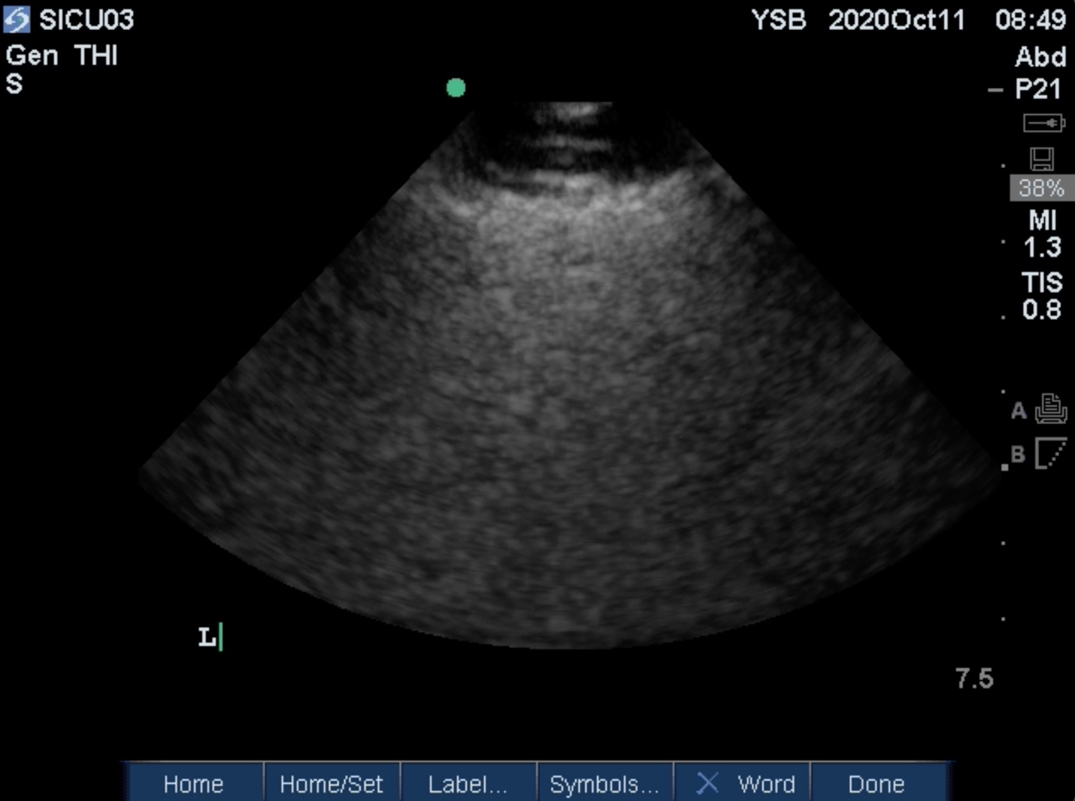

Figure S17: Still image taken from Video 17 of subcutaneous emphysema.

